CP Practical Code  
  
#include <stdio.h>

#include <string.h>

struct cricket

{

char PlayerName[20];

char TeamName[20];

float BattingAverage;

};

int main()

{

struct cricket s[50], t;

int i, j, n = 50;

float p;

printf("Enter Data Of %d Player\n", n);

for (i = 0; i < n; i++)

{

printf("\nEnter Player Name,Team Name And Bating Average For Player %d :- \n", i + 1);

scanf("%s %s %f", s[i].PlayerName, s[i].TeamName, &p);

s[i].BattingAverage = p;

}

for (i = 1; i <= n - 1; i++)

{

for (j = 0; j <= n - i; j++)

{

if (strcmp(s[j - 1].TeamName, s[j].TeamName) > 0)

{

t = s[j - 1];

s[j - 1] = s[j];

s[j] = t;

}

}

}

printf("\nAfter Teamwise Sorting...Player List Is");

for (i = 0; i < n; i++)

{

printf("\n%-20s %-20s %.2f", s[i].PlayerName, s[i].TeamName, s[i].BattingAverage);

}

}

Code on Compiler:-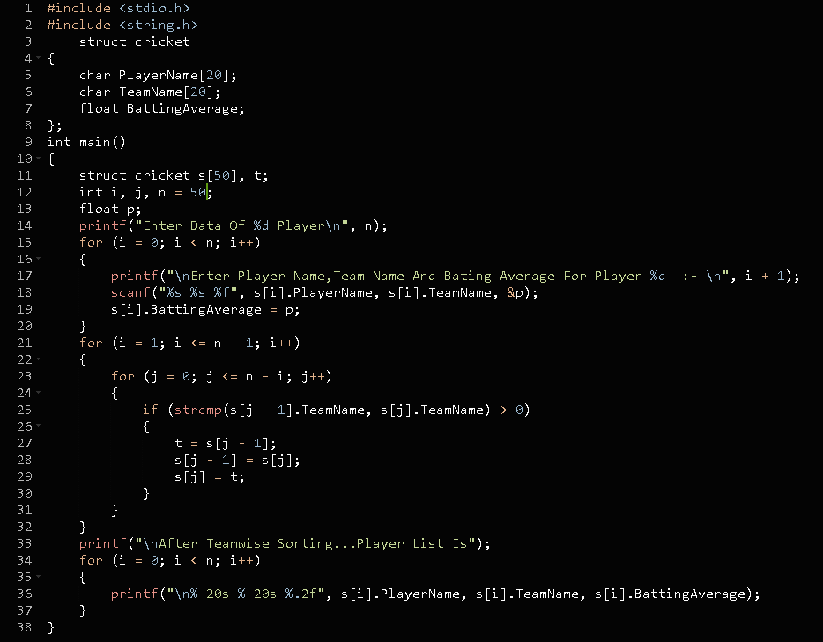

**Output of the Code:-**

I took the output of only 5 values for the sake of simplicity, but the code submitted above works for 50 players.